**This document is a direct translation and may contain typographical and grammar errors.**

Translated from Chinese (Simplified) to English - www.

**ZC-TME**

**Tire modeling and evaluation system**

**(user's Guide)**

**Author: Taiyuan Zhang**

Content

**1. Software summary**

**2. Application area**

**3. Main features**

**4. Safety mechanism**

**5. Operation environment**

**6. Operation**

# A software introduction

## 1.1 Background

The dynamic model that represents the mechanical properties of the tire is a necessary input for the vehicle simulation design, so the establishment of the six-component tire force and its model is very important. In order to allow tire dynamics analysis engineers to quickly and conveniently generate magic formula tire models, this software was specially developed. This software was developed by the Meridian Research Institute of Zhongce Rubber Group Co., Ltd. and is used by the Institute for tire dynamics analysis.

## 1.2 Purpose

This manual is written by our company's tire technical engineers using the company's "ZC Tire Modeling and Evaluation System". We hope that this manual will enable them to use the system to complete tire model identification, tire six-component force data interpolation prediction, and tire performance comparative analysis, etc. This manual introduces the functions and usage of the system.

The tire six-component force MF model identification system mainly consists of six modules: tire six-component force data reading and storage, model parameter identification, identification result output, pac94 3 air pressure interpolation, model comparison analysis and help. See Figure 1 for the menu interface:

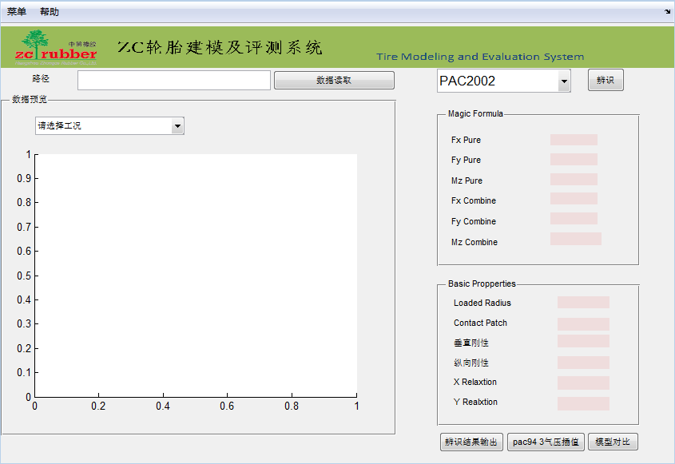

figure 1

## 1.3 Performance

The system has stable performance, high model identification accuracy and high calculation efficiency, and meets the requirements of tire modeling and model comparative analysis.

## 1.4 References

1 National Standard for Computer Software User Manuals

2. MATLAB GUI Design Learning Notes compiled by Luo Huafei

Beijing University of Aeronautics and Astronautics Press

# 2. Application areas

This software is mainly used in the fields of tire dynamics modeling and tire six-component force performance evaluation.

# Three main function descriptions

## 3.1 Data functions

①Data import: Import data in *.mat format to facilitate transplanting data results to other computers for calculation.

②Data saving: Save the read test data as a file in *.mat format to the specified path.

③Data reading: Read the original tire modeling test data, including sideslip, longitudinal slip and compound working conditions, etc.

④Data preview: Classify and preview the imported test data, such as lateral force VS side slip angle under pure working conditions, righting moment VS side slip angle, longitudinal force VS slip rate, lateral force under combined working conditions VS side slip angle, righting moment VS side slip angle, longitudinal force VS slip rate, and slack length VS travel distance

## 3.2 Identification function

① PAC94 model identification: Perform magic formula PAC94 tire model identification on the imported tire modeling data.

②PAC2002 model identification: Perform magic formula PAC2002 tire model identification on the imported tire modeling data.

③Identification accuracy display: Displays the identification accuracy of PAC94 tire model and the identification accuracy of PAC2002 tire model respectively.

④ Model parameter value output: Output the PAC94 tire model parameter identification results and the PAC2002 tire model parameter identification results respectively.

## 3.3 Interpolation calculation function

① Tire model reading: Read the magic formula PAC94 tire model parameter identification results.

② Calculate the PAC94 tire model parameters of the target air pressure: According to the read magic formula PAC94 tire model parameter identification results, after setting the target air pressure, the PAC94 tire model parameter values ​​under the air pressure conditions can be calculated.

③Drawing: Based on the calculated PAC94 tire model parameter values ​​under the target air pressure, the background calculation is used to draw the tire lateral force VS side slip angle and backing moment VS side under any set load or camber angle under the target air pressure. Angle curve.

④Graphics clearing: All curves in the drawing area can be cleared at one time.

⑤Save: Save the data under the currently drawn graph to the specified path, such as the data point set of tire lateral force vs. side slip angle and backing torque vs. side slip angle.

## 3.4 Comparative analysis function

① PAC94 model import: Read the magic formula PAC94 tire model file in *.tir format.

②Characteristic value calculation: Based on the read PAC94 tire model file, calculate the tire side deflection, alignment and longitudinal slip characteristic index values

## 3.5 Exit function

Click Menu-Exit to exit this software.

## 3.6 Help function

Click Help-Help Document to open the instruction file for this software.

# 4 safety mechanisms

The system has a security and confidentiality mechanism, and you need to be authorized to log in with an account and password before you can enter it.

# 5 operating environments

## 5.1 Hardware equipment

Microcomputer Lenovo Ben3 and other models with equivalent or above configurations

## 5.2 Support software

Development toolsMATLAB2014a

# Six software operations

## 6.1 Instructions for using main objects in the operation interface

The operation of this system adopts a unified user interface. The main objects in the operation interface are introduced below, and will not be explained in detail when encountering such objects in the future.

The main objects in the operation interface include 8 categories:

1 button 2 text box 3 drop-down list box

The usage of various types of objects is introduced as follows:

1 button

① Data reading:This icon is the data reading button, which is used to select the raw data of the tire model that needs to be identified.

②Identification:This icon is the identification button, used to identify data.

③ Identification result output:This icon is the identification result output button, which is used to output the identification results in excel format.

④ pac94 3 pressure interpolation:This icon is the interpolation button of the pac94 model at three air pressures, which is used to predict the pac94 model at the fourth air pressure given the pac94 model at three air pressures.

Model comparison:This icon is a model comparison button, which is used to compare the mechanical properties of two tire models with the pac94 model under known three air pressures to predict the pac94 model under the fourth air pressure.

2 text box

1) Illustration: The text box is as shown in the figure shown

2) Function: used to input or display data

3) Operation: If in the input state, the cursor stops at the left border of the text box and input relevant information according to the requirements of the data type.

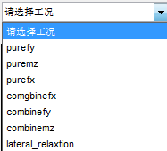3 drop-down list box

1) Illustration: The drop-down list box is as shown in the figure

2) Function: Used for selective input of certain fewer and fixed multiple items to save input time and ensure the accuracy of input.

3) Operation: Use the mouse to hold down the up and down arrows to find the appropriate option. Once found, click once to complete the input of the field.

## 6.2 Instructions for use

This system has only one window interface, including data reading and storage, data identification, identification result output, pac94 3 pressure interpolation, model comparison and help.

### 6.2.1 Tire model identification

As shown in Figure 4, the function here performs tire model identification on six-component tire force test data of a certain specification. It includes four functions: data reading and storage, data preview, data identification, and identification result output.



Figure 4

6.2.1.1 Data reading

The function here is to read the six-component force test data under a certain folder, which can be selected by clicking the button or selecting the path, as shown in Figure 5.



Figure 5

6.2.1.2 Data preview

The function here is to preview the six-component force data under a certain working condition through the drop-down list box, as shown in Figure 6.

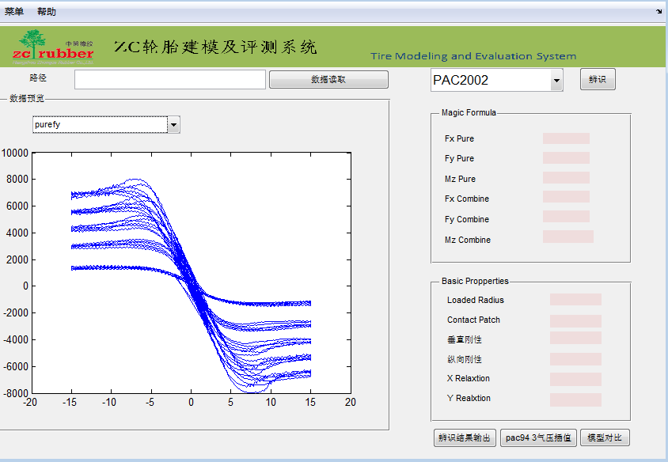Figure 6

6.2.1.3 Data storage

This function is located under the menu bar and is used to save the imported data as a data file in .mat format.

6.2.1.4 Data import

This function is located under the menu bar and is used to import previously saved .mat files into the system.

6.2.1.5 Model identification

The function here is to perform tire model identification on test data. You can select different tire models through the drop-down text box. Right-click on the Magic Formula section to view the identification result graph and original data, as shown in Figure 7.

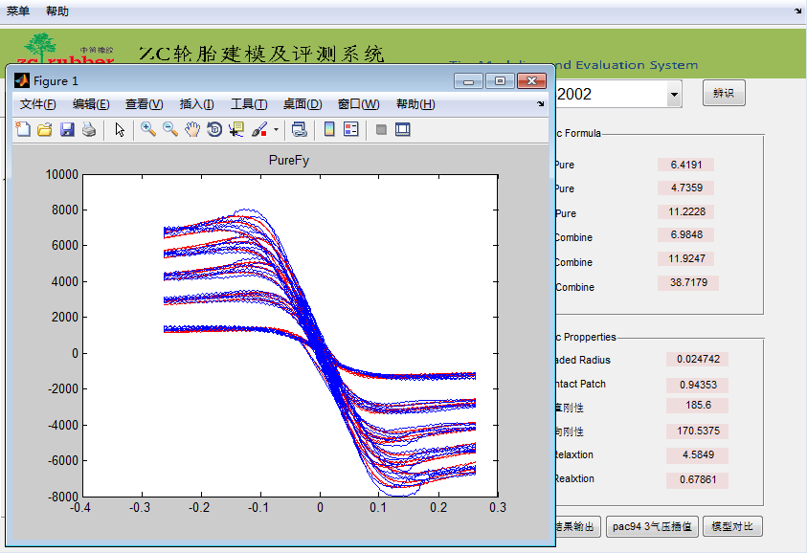

Figure 7

6.2.1.6 Identification result output

The function here is to output the identification results of the identified tire model, and the output format is excel format.

### 6.2.2 pac94 three pressure interpolation

The function here is to import pac94 tire models with three air pressures, and then predict pac94 tire models with other air pressures, as shown in Figure 8.

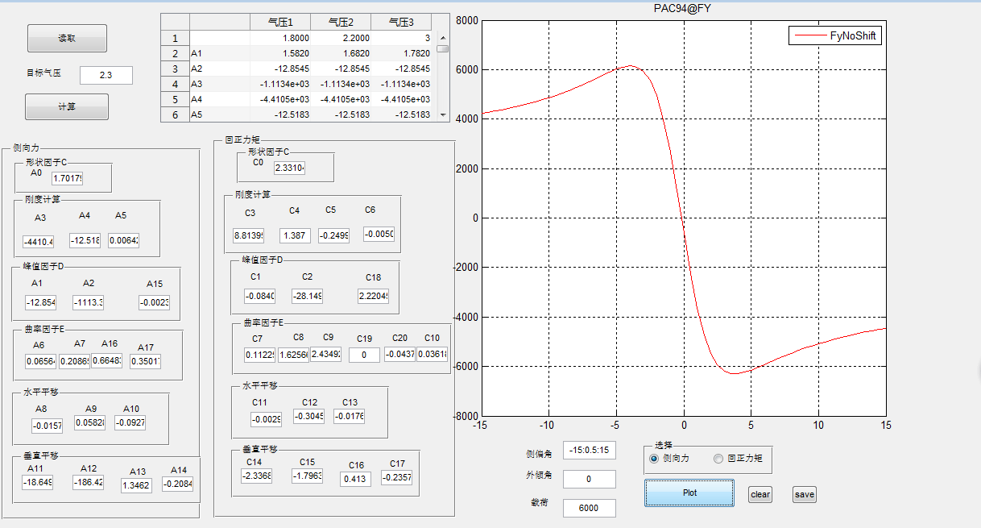

Figure 8

6.2.2.1 Tire model reading

The function here is to read the pac94 tire model with 3 air pressures. The specific tire parameters will be displayed in the built-in excel, as shown in Figure 9.

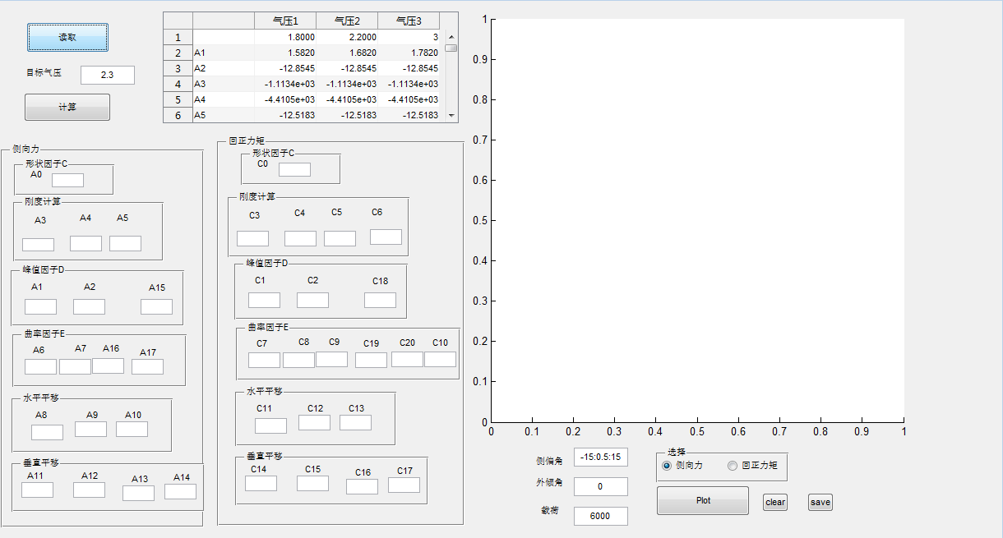

Figure 9

6.2.2.2 Pac94 tire model for calculating target air pressure

The function here is to calculate the pac94 tire model of the target air pressure. The specific parameters will be displayed in the text box, as shown in Figure 10.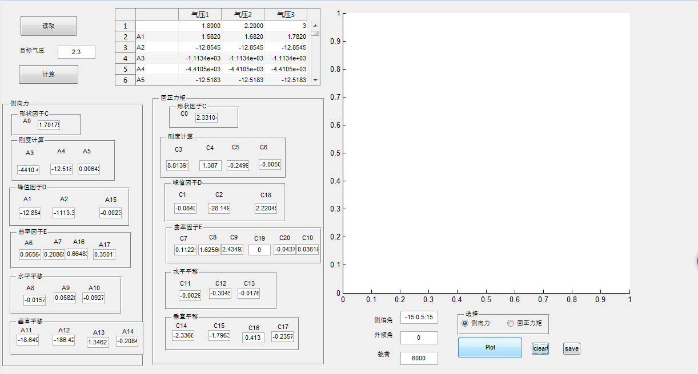

Figure 10

6.2.2.3 Drawing

The function here is to draw the graph of the tire model with the target air pressure. The graph can be drawn by setting the tire load, slip angle, camber angle and selecting the pattern type, as shown in Figure 11.



Figure 11

6.2.2.4 Graphic clearing

The function here is to clear the graphics so that you can continue drawing graphics.

6.2.2.5 Save

The function here is to save the tire model and calculation result data of the target air pressure in excel format.

### 6.2.3 Model comparison

The function here is to import two tire models and compare the tire mechanical properties, as shown in Figure 12.

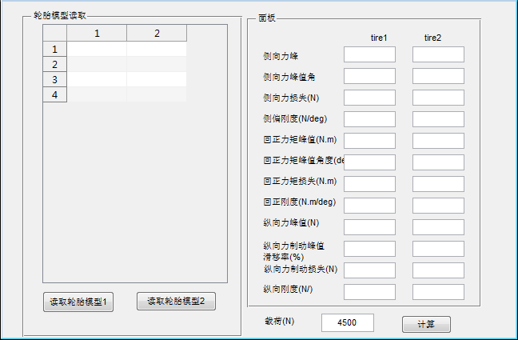

Figure 12

6.2.3.1 Tire model import

The function here is to import the .tir file of the tire model. As shown in Figure 13.

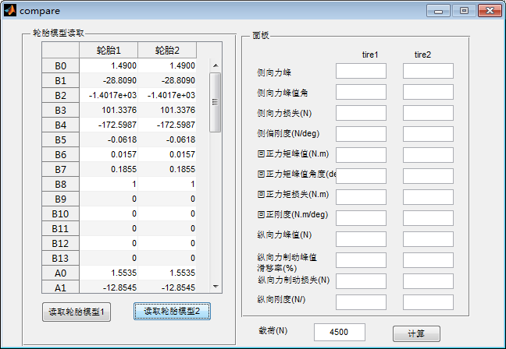

Figure 13

6.2.3.2 Eigenvalue calculation

The function here is to input the tire load and camber angle, and calculate the tire mechanical characteristic value under this condition, as shown in Figure 14.

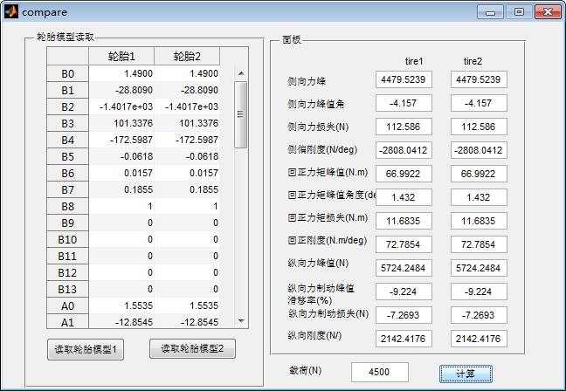

Figure 14

### 6.2.4 Exit

This function is located under the menu bar and its function is to close the software.

### 6.2.5 Help

This function is located under the menu help and its function is to open the instruction manual of the software.